**GROUP 8:**

**BAGADIONG**

**FAJARDO**

**MACHINE PROBLEM #5 (MATLAB SOLUTION)**

**Test:**

Input function x(n): sin((3*pi/100)*n)

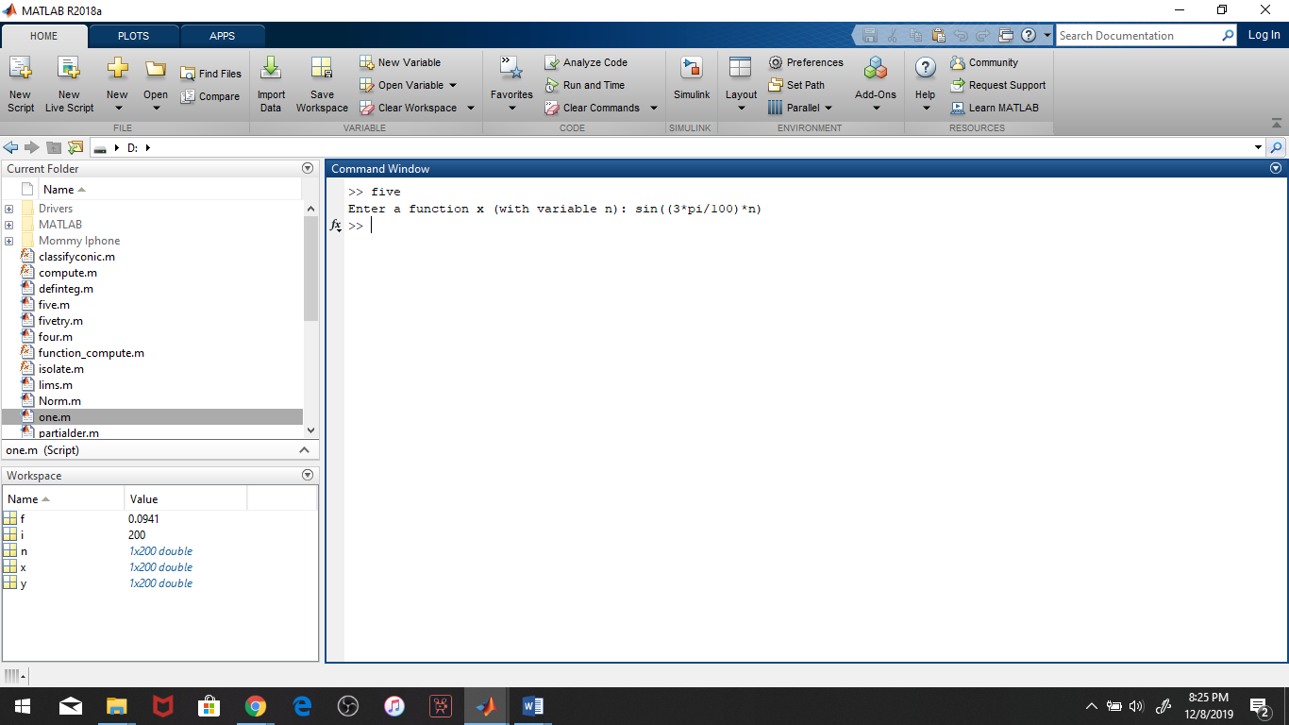

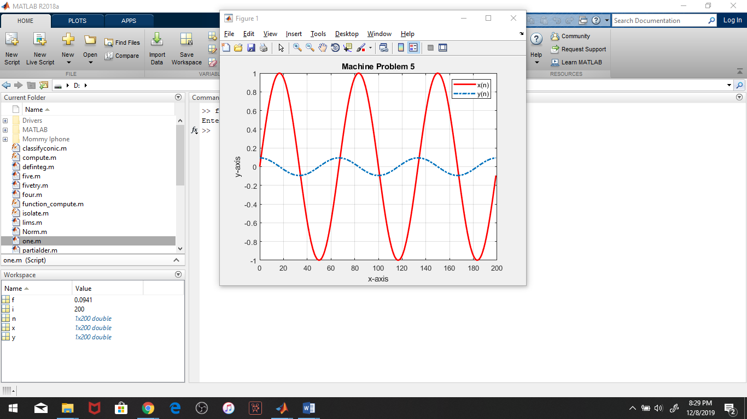

**Script file:**

